Applying Cryptography in Real-World Scenarios

Introduction

Cryptography is the practice of securing information by transforming it into a form that only authorized parties can understand. In today’s digital world, cryptography plays a vital role in protecting sensitive data against unauthorized access, tampering, and impersonation.
This project demonstrates the practical application of cryptography using real tools in a Linux environment. The project focuses on encryption, decryption, hashing, and public key cryptography to show how confidentiality, integrity, and authenticity are achieved in real-world systems.

Project Objectives

The objectives of this project are:
- To understand basic cryptographic concepts
- To apply encryption and decryption to protect files
- To verify data integrity using hashing
- To demonstrate secure communication using public and private keys
- To relate cryptographic techniques to real-world cybersecurity scenarios

Tools and Environment Used
- Operating System: Linux (Kali Linux)
- Terminal Tools:
  - OpenSSL
  - GPG (GNU Privacy Guard)
- Algorithms Used:
  - AES-256 (Symmetric Encryption)
  - SHA-256 (Hashing)
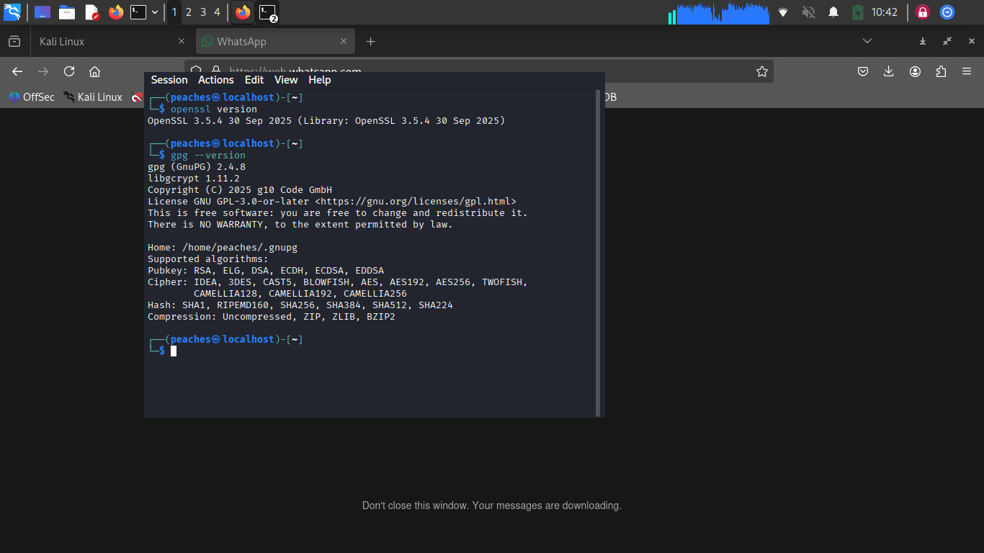
  - RSA-3072 (Asymmetric Encryption)

Symmetric Encryption (Confidentiality)

Step 1: Creating a File

A simple text file was created to simulate sensitive data.

Message content:My favorite food is waakye.

The message was saved in a file as food.txt

Step 2: Encryption Using AES-256
AES (Advanced Encryption Standard) is a symmetric encryption algorithm that uses the same password for both encryption and decryption.
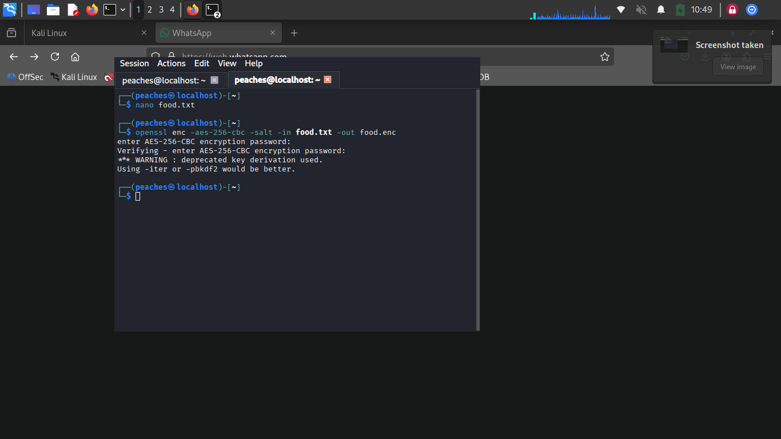
Encryption command used: openssl enc -aes-256-cbc -salt -in food.txt -out food.enc

Encrypted Output:
- The resulting file food.enc is unreadable
- Access is protected by a password

Step 3: Decryption Process

The encrypted file was decrypted using the same password.
Decryption Command Used: openssl enc -aes-256-cbc -d -in food.enc -out food_decrypted.txt
Decrypted Output:
This confirms that the decrypted file matches the original content.
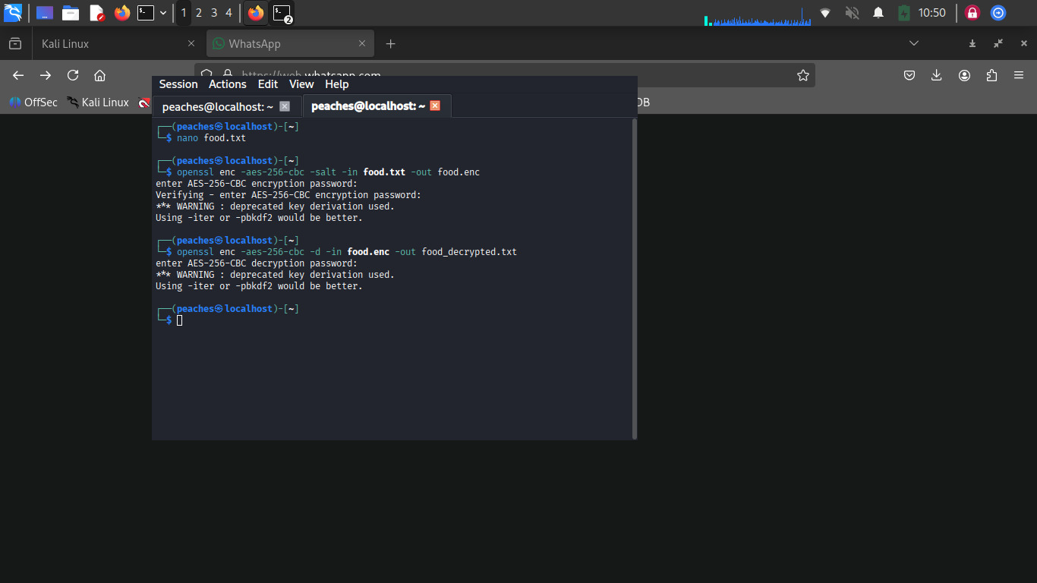

Objective Achieved:
Confidentiality : Only authorized users with the correct password can access the message.

Hashing and Integrity Checking

Step 1: Hash Generation (Before Modification)
Hashing creates a unique digital fingerprint for data. SHA-256 was used.
Command Used: sha256sum food.txt
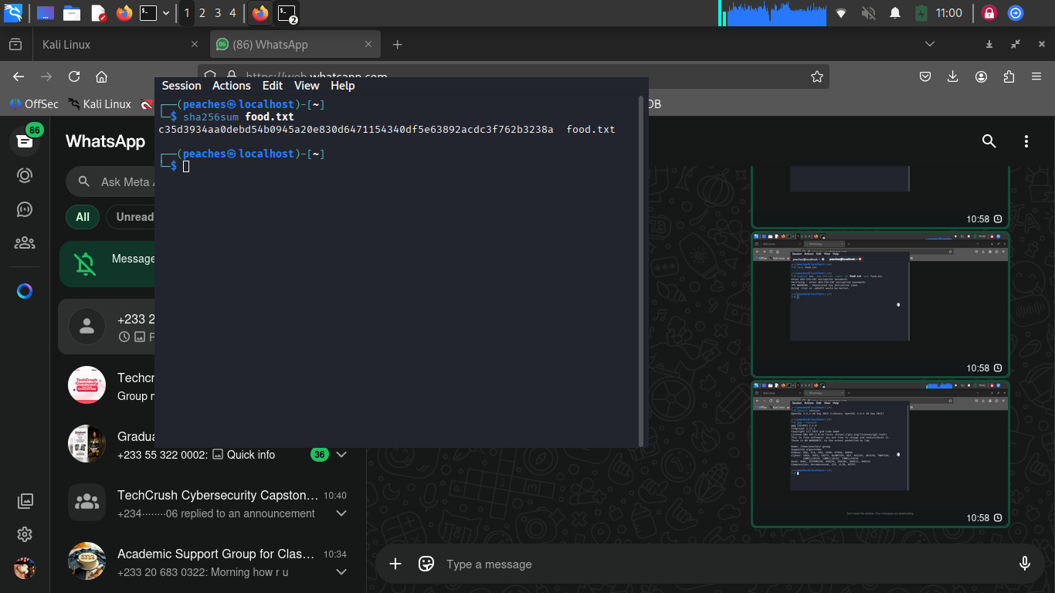
Hash Output: c35d3934aa0debd54b0945a20e830d6471154340df5e63892acdc3f762b3238a

Step 2: File Modification and Re-Hashing
The message was slightly modified to: My favorite food is waakye and khebab.
The hash was then generated again after this modification using the same command
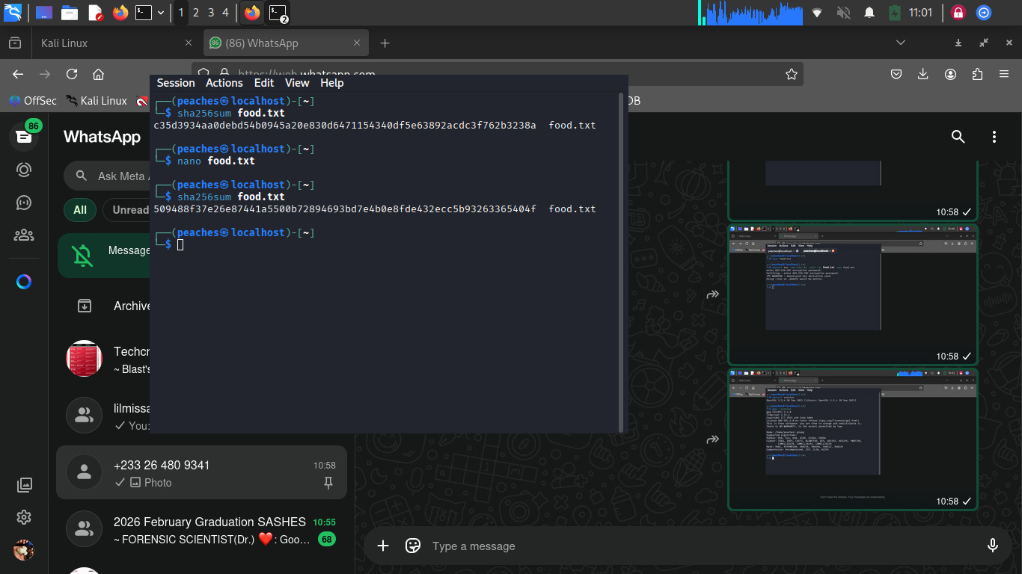
New Hash Output: 509488f37e26e87441a5500b72894693bd7e4b0e8fde432ecc5b93263365404f

Step 3: Observation
- Even a very small change in the file resulted in a completely different hash value
Objective Achieved:
Integrity : Hashing helps detect tampering or unauthorized modification.

Public Key Encryption and Secure Messaging

Key Pair Generation

Public and private keys were generated using GPG.

You use a Public Key to encrypt and a Private Key to decrypt.

To generate a key pair:

gpg --full-generate-key
Select 1 RSA and RSA
chose key size 3072
Specify how long the key should be valid
Enter your name: AYORINDEGmail: ayoisomoakeju@gmail.com
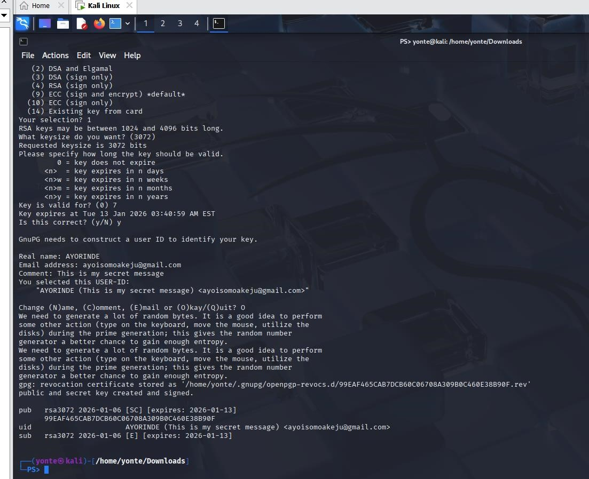
create a passcode

Encrypt with the public key:
gpg --encrypt --recipient "AYORINDE or ayoisomoakeju@gmail.com" secret.txt

Output:
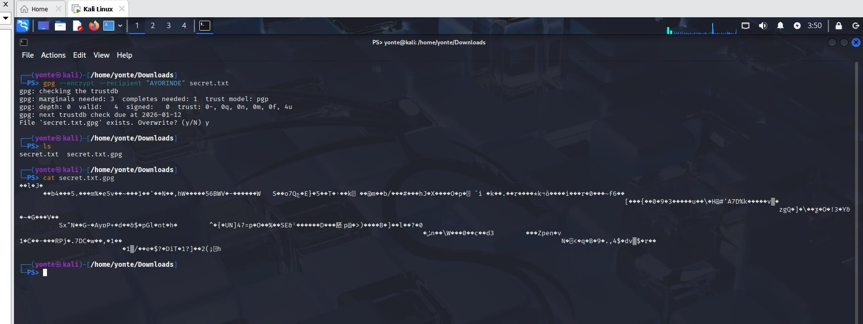
secret.txt.gpg

Decrypt with the private key:
gpg --decrypt secret.txt.gpg > secret.txt

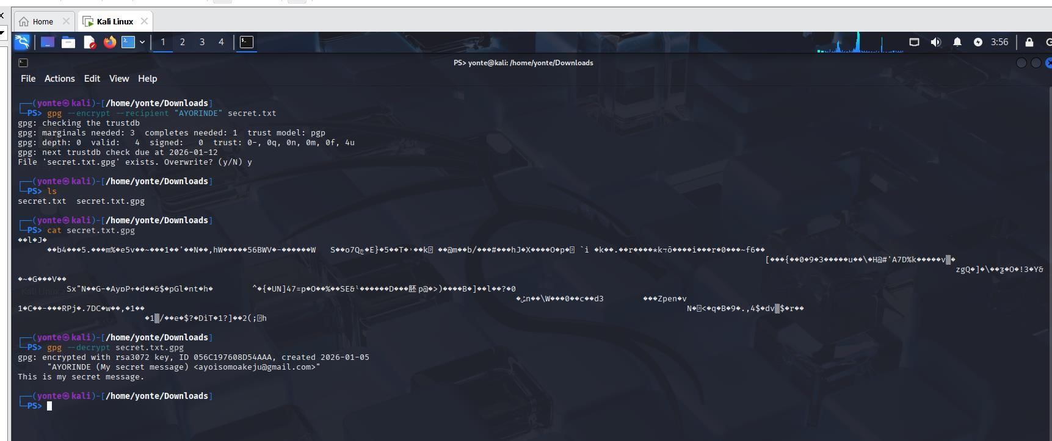

2. Export Public Key gpg --armor --export > secret.txt.asc
You can open the file to see the key (secret.txt.asc)

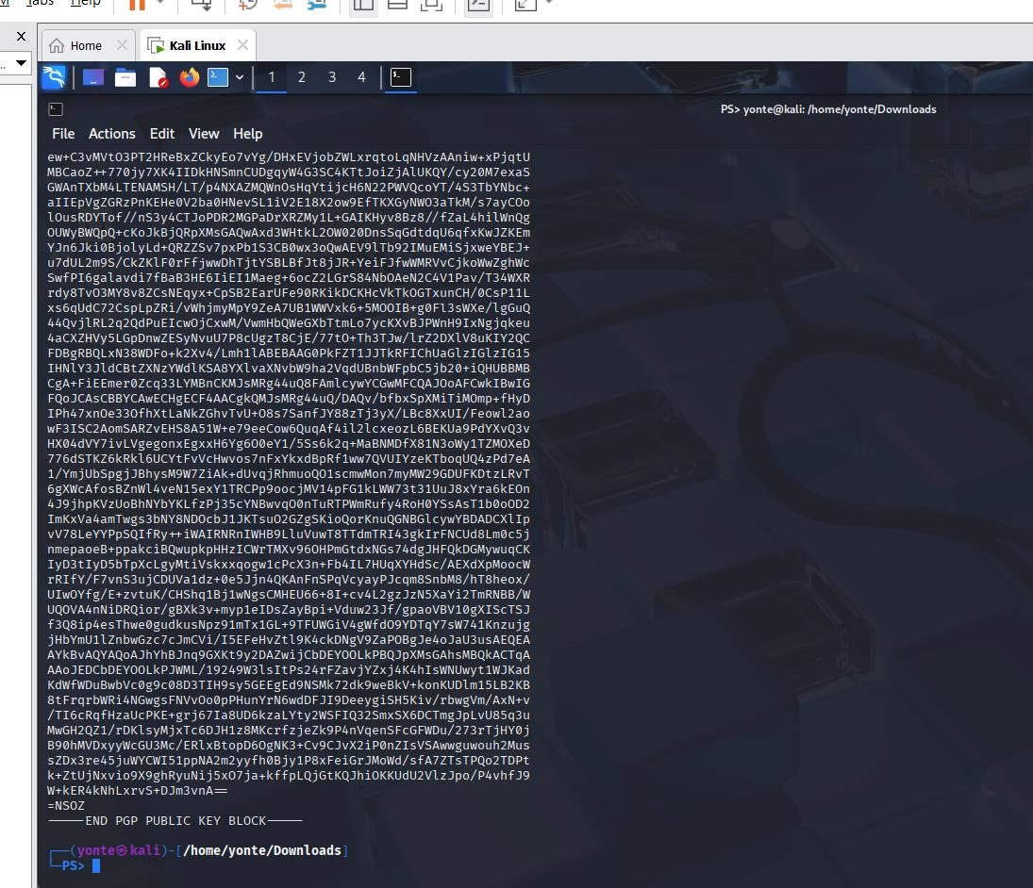

3. Sign a File: gpg --clearsign documnet.txt.asc
This creates documnet.txt.asc. It contains your original text plus a "Digital Signature." If
anyone changes even one letter of the text, the signature will fail validation.

Bonus: Secure Email User Guide

A Beginner's Guide to PGP Messaging on Linux

1. The Golden Rule of Keys
To use secure email, you use Asymmetric Cryptography. Think of it like a mailbox: The Public Key: This is your "Mailing Address." Give it to everyone. It allows people to lock messages for you.
The Private Key: This is your "Physical Key." Never share it. Only this key can unlock the messages you receive.

2. Generating Your Identity
Before you can send or receive secure emails, you must create your key pair.
Open your terminal and type:
Select RSA and RSA (Option 1).
Choose a key size of 3072 or 4096 for maximum security.
Enter your real name and email. This becomes your "UID" (User ID).

3. Sharing Your "Address"
To receive an encrypted email, your friend needs your Public Key.
Export your public key to a file:
Email this .asc file to your friend. It is perfectly safe for anyone to see this file.

4. Sending an Encrypted Email
When you want to send a secret message to a friend: Import their public key first: gpg --import friend_key.asc Write your message in a text file (e.g., secret.txt).
Encrypt and Sign it:
Encryption ensures only they can read it.
Signing proves it actually came from you.

5. Reading a Secure Email
When you receive an encrypted file (usually ending in .gpg or .asc):
Run the decryption command:
GPG will ask for your passphrase, unlock the message, and verify the sender's signature.

Final Report Section: Expected Outcomes & Conclusion

Expected Outcomes Reached
Through the execution of this project, I have successfully demonstrated the following: Practical Tool Proficiency: I have moved beyond theoretical knowledge to effectively use GPG within a Linux environment to secure data.
- Cryptographic Implementation: I have demonstrated the difference between Symmetric encryption (for speed and storage) and Asymmetric encryption (for secure transmission and identity).
- Verification of Integrity: I proved that hashing is a binary "all-or-nothing" check, where even the smallest change to a dataset is immediately detectable.

Conclusion: Supporting Cybersecurity Goals

The techniques applied in this simulation are the foundation of modern digital trust. By implementing these scenarios, I have illustrated how the CIA Triad is upheld:

- Confidentiality: Achieved through AES-256, ensuring that data at rest (backups) and data in transit (email) remain unreadable to unauthorized parties.

- Integrity: Upheld through SHA-256 hashing, providing a mathematical guarantee that data has not been modified or corrupted.

- Authenticity: Established via Digital Signatures, which solve the problem of impersonation in digital communication.

5. Challenges

- Syntax Precision: Cryptography is unforgiving. A single missing character in a GPG command or a forgotten -d flag during decryption results in failure. This highlighted the importance of automation and scripting in real-world systems to prevent human error.

- The "Hidden" Modification: During the hashing phase, I realized that even invisible changes—like adding a trailing newline or a space at the end of a file—completely change the SHA-256 output. This demonstrated how sensitive integrity checks are to even the smallest data corruption.

Real-World Application
- Key Management vs. Encryption: I learned that while the math of AES-256 is nearly unbreakable, the management of the keys is the weak point. In a real-world company, losing the private key used for backups would mean a permanent loss of data (e.g., the "locked out of my Bitcoin wallet" scenario).

- Software Distribution: This project mirrored how Linux distributions are distributed.
When I download an Ubuntu ISO, I check its SHA-256 hash against the official website.
Now I understand that I am not just checking for a "bad download," but protecting myself against a "Man-in-the-Middle" (MitM) attack.

- Regulatory Compliance: Encrypting backups isn't just a good idea; it’s a legal requirement in many industries (like HIPAA for healthcare or GDPR for privacy). This project simulated the exact steps a sysadmin takes to ensure data at rest is compliant.

